Comments / Feedback / Suggestions

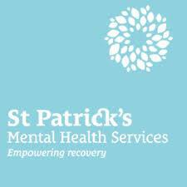

At St Patricks Mental Health Services we are committed to providing the highest possible standards of care to everyone who uses our services.

If you have any comments, feedback or suggestions, please complete this form and place it in any of the comment boxes located around the hospital. Your comments, feedback and suggestions are very important to us and help us to develop and improve our services.

St Patrick’s Mental Health Services
St Patrick’s University Hospital | St Edmundsbury Hospital | Willow Grove Adolescent Unit
James’s Street  Dublin 8  Phone: 01 – 249 3200 | Lucan  Co. Dublin  Phone: 01 – 621 8200 | James’s Street  Dublin 8  Phone: 01 – 249 3200

Additional Supports
Information & Support Services 01 – 249 3333
Clinical Governance Office clinicalgovernance@stpatsmail.com
St Patricks Mental Health Services Website stpatricks.ie

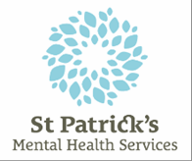
Your Feedback

If you need help filling out this form, a staff member will be happy to help you
Staff
Visitor
Which of the following are you?

Inpatient Out-patient

Please give us your comments / feedback / suggestions:

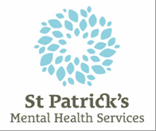
Your Details

Filling in your personal details is optional. However, we can only contact you if you provide your details.

Your Contact Details – please print this information clearly
Name
Address
Phone number
Email address

Would you like feedback from us? Yes |  | No
If ‘YES’ – how would like to receive that feedback?
By Phone | By Email | Written, by post | In person | Don’t mind

Office Use Only

Ref: Ward:

Date: Input by:

Thank you for taking the time to provide us with your feedback

