Handouts
https://compassionatemind.co.uk/

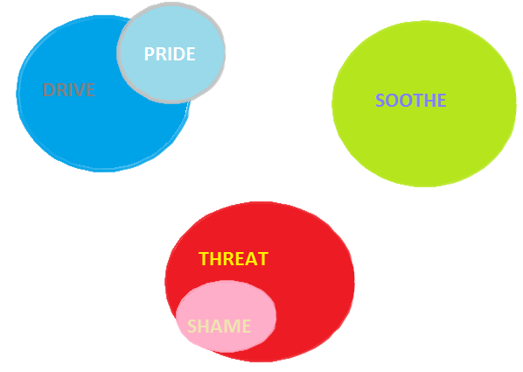

Exercise to try at home or with a client: Draw your own three circles and try to think about whether they are in or out of balance; allow your drawing to show which system you spend most of your time in.

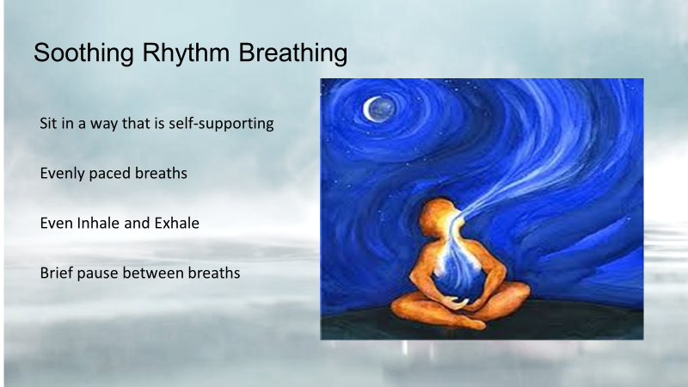

Soothing Rhythm Breathing – Script

Invite participants to take a soothing object if they would find this helpful – play-doh, a teddy, a soft ball etc.

Place both of your feet flat on the floor about shoulder’s width apart and rest your hands on your legs. Bring your shoulders so that they come to rest over your hips. Close your eyes or look down at the floor if you prefer. Allow yourself to have a gentle facial expression maybe a slight smile.

Now gently focus on your breathing. As you breathe try to allow the air to come down into your diaphragm. Just notice your breathing and play with your breathing. Breathe a little faster or a little slower until you find a breathing pattern that, for you, seems to be your own soothing, comforting rhythm. It is like you are checking in, linking up, with the rhythm within your body that is soothing and calming to you.

What you will usually find is that your breathing is slightly slower and deeper than normal. Ensure that the breaths in and out are smooth and even. So, for example, notice if you’re breathing in a bit too quickly or collapsing the out breath and play with your breathing to find a rhythm to the in breath and out breath, a soothing rhythm to your breathing.

I will give a breath count and you are welcome to follow that or to follow your own count. If you would like to breath with me then exhale now and breathe in…. 2……3 ……. Hold…….out…….2…….3……. hold…..(repeat by 5-10 cycles). Continue with this count or with your own count for another 5 breaths.

Now you can spend a little while – for as long as you wish - just focusing on your breathing, just noticing the breath coming in and then the air moving out. Just focus on that for a while…………………………Remember that it is perfectly ok for your mind to wander. Simply notice it happening with curiosity about where your mind has gone and then gently guide your attention back to an awareness of your breath as best as you can.

Now sense the flow of air coming in and out of your nostrils…. gently observing….no need to change anything…..just allowing things to be as they are.

If you find focusing on your breathing a bit difficult (and some people do) then allow your attention to rest on an object. Find something you might like to hold such as a smooth stone or a soft ball – something that gives you the feeling of gentleness and calmness. Now as you just focus on your
breathing also focus on the object that you’re holding noticing how it feels in your hand, resting your gaze on your object as best as you can…. staying with the sensations of holding it in your hand.

When you feel ready, slowly open your eyes and bring yourself back to the present moment. Sometimes it helps if you just have a gentle stretch and a deep breath to prepare you to carry on with your day.

Worksheet For Building Your Compassionate Companion

How would you like your ideal caring, compassionate image to look/appear; what are its visual qualities?

How would you like your ideal caring, compassionate image to sound, e.g. tone of voice?

What other sensory qualities can you give to it, e.g. its smell, or textures?

How would you like your ideal caring, compassionate image to relate to you?

How would like to relate to your ideal caring, compassionate image?

