Comments / Feedback / Suggestions

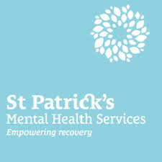

St Patricks Mental Health Services is committed to providing the highest possible standards of care to everyone who engages with our services.

If you have any comments, feedback or suggestions, please complete this form and place it in any of the comment boxes located throughout the hospital and clinics. Your comments, feedback and suggestions are very important to us and help us to develop and improve the services that we provide.

St Patricks Mental Health Services

St Patricks University Hospital St Edmundsbury Hospital Willow Grove
James’s Street, Lucan, Adolescent Unit,
Dublin 8 Co. Dublin James’s Street,
Dublin 8
Ph: 01 2493200 Ph: 01 6218200 Ph: 01 2493200

Information & Support Service Ph: 01 2493333

Email clinicalgovernance@stpatsmail.com

WWW www.stpatricks.ie

Mental Health Matters

Please indicate whether you are currently:

Inpatient Out-patient Visitor Staff

Please give us your comments / feedback / suggestions:

_________________________________________________________________________________________________________________________________________________________________________________________________________________________________________________________________________________________________________________________________________________________________________________________________________________________________________________________________________________________________________________________________________________________________________________________________________________________________________________________________________________________________________________________________________________________________
_________________________________________________________________________________________________________________________________________________________________________________________________________
________________________________________________________________________________________________________________________________________________________________________________________________________________________________________________________________________________________________________________________________________________________________________________________________________________________________________________________________________________________________________________________________________________________

Occasionally, comments received may be used on the St Patricks Mental Health services website and / or other publications.
All comments used will remain anonymous. If you do not wish this information to be published / used please tick here

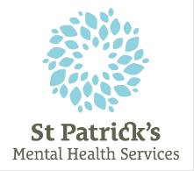
Mental Health Matters

Signing this form and / or filling in personal details is optional

However, if you would like to be contacted or if you have reason to complain about any person, whether this is a staff member or other, please be aware that this cannot be followed up without your details.

Please print your name and address clearly:

Name: ______________________________________

Address: ______________________________________
______________________________________
______________________________________
______________________________________
Telephone: ______________________________________
Email: ______________________________________

If you require assistance in completing this form, a staff member will be happy to help you.

Please tick here if you would like to be contacted with feedback

If you would like feedback, please indicate how would you like to receive that feedback:

Telephone Email Written, by Post In Person

Office Use Only

Ref: _____________________ Date: ________________

Ward: _____________________ Input by: ______________

For Internal Hospital Use Only

Date Received: / / Area: ______________________________
From: Staff Service User Mail Verbal Other
Relates to: Direct Patient Care Indirect Patient Care
Feedback Requested: Yes No

Complaint / Comment assigned to
CEO |  | DOS
DON |  | HR
DON St Eds |  | CNM WGAU
MD |  | OT
Household Manager |  | Con Council
Catering Manager |  | Finance
Pharmacy |  | PM – Programmes
PM – Deans |  | PM – Quality
R&S |  | Admin Mgr
IT Mgr |  | Med Rec Mgr

Via: Email Internal Mail Hardcopy

Additional Notes
_____________________________________________________________________________________________________________________________________________________________________________________________________________________________________________________________________________________________________________________________________________________________________________

